**Assessment type (🗹):**

☐ Questioning (Oral/Written)

☐ Practical Demonstration

☐ 3rd Party Report

☒ Other – Project/Portfolio (*Part of assessment task 1)*

**Assessment Resources:**

|  |
| --- |
| * PC * Google * Computer components PowerPoint * Linux Virtual Machine |

**Assessment Instructions:**

|  |
| --- |
| Instructions to the assessor:  This lab is a part of Assessment Task 2 portfolio, it is a practical lab based on the performance criteria requirements of the unit. Each student should be given a copy of this lab to complete either in class or out of class. As the student completes each section of this lab you should verify, check off and sign off the section (Use this document as the observation checklist). Use the assessor section at the bottom to provide feedback to the student if required.  See the instructions to the student section for the remainder of the instructions.  Instructions to the student:  This lab consists of activities that you perform on the hardware and software nominated concerning preventative maintenance and base level troubleshooting procedures.  There are several short answer questions where you will be asked to research and answer questions relating to these topics. You are encouraged to use the documentation in the resource section to help you work on the requirements.  Time:  Nominally 120 mins  Due date:  This lab is part of assessment 1 and inherits its due date.  Submission instructions:  When the lab is complete, submit the assessment via Blackboard.  Reasonable adjustment:  Should there be difficulty with reading technical manuals relating to disability of language and literacy levels you are encouraged to use online video tutorials similar to the following:   * https://www.youtube.com/watch?v=HBP8_LqBj44 |

|  |  |
| --- | --- |
| Your Student ID:  20145454 | Your Name: Rajib Hossain Khan |

**Lab: Linux System Administration and Security Fundamentals**

**Objective**

In this lab, students will perform essential Linux system administration tasks, including managing processes, installing packages, handling user accounts, setting file permissions, managing services, and using networking commands.

**Instructions for Students**

**Step 1: Managing Processes**

1. Open a terminal and use the ‘top’ command to view running processes.
   * Observe CPU and memory usage.
   * Identify the process ID (PID) of a high-resource-consuming process.
   * Take a screenshot of your top output.

*top*

**Screenshot**

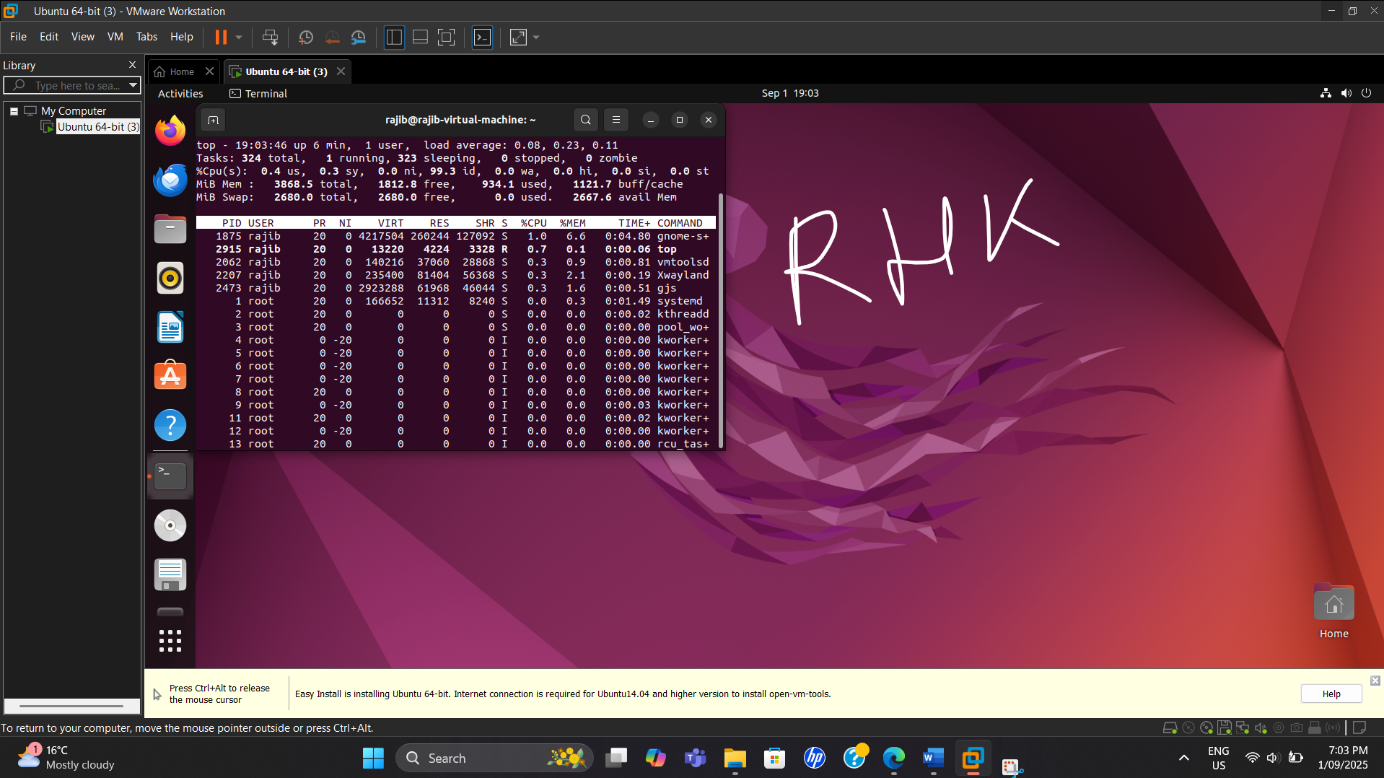

1. Use the ps command to list active processes.
   * Run ps aux and ps -ef to explore different output formats.
   * Identify your current user processes using ps -u $USER.

**Screenshot**

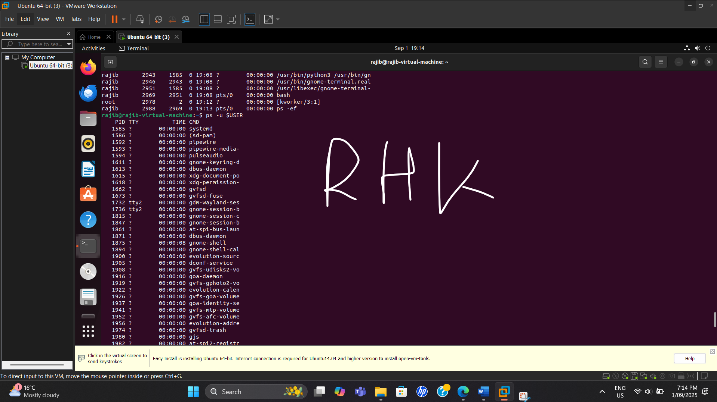

1. Kill a process using the kill command:
   * Use kill <PID> to terminate a process.
   * Use kill -9 <PID> if a process does not terminate with the default signal.
   * Take a screenshot of the output.

**Screenshot**

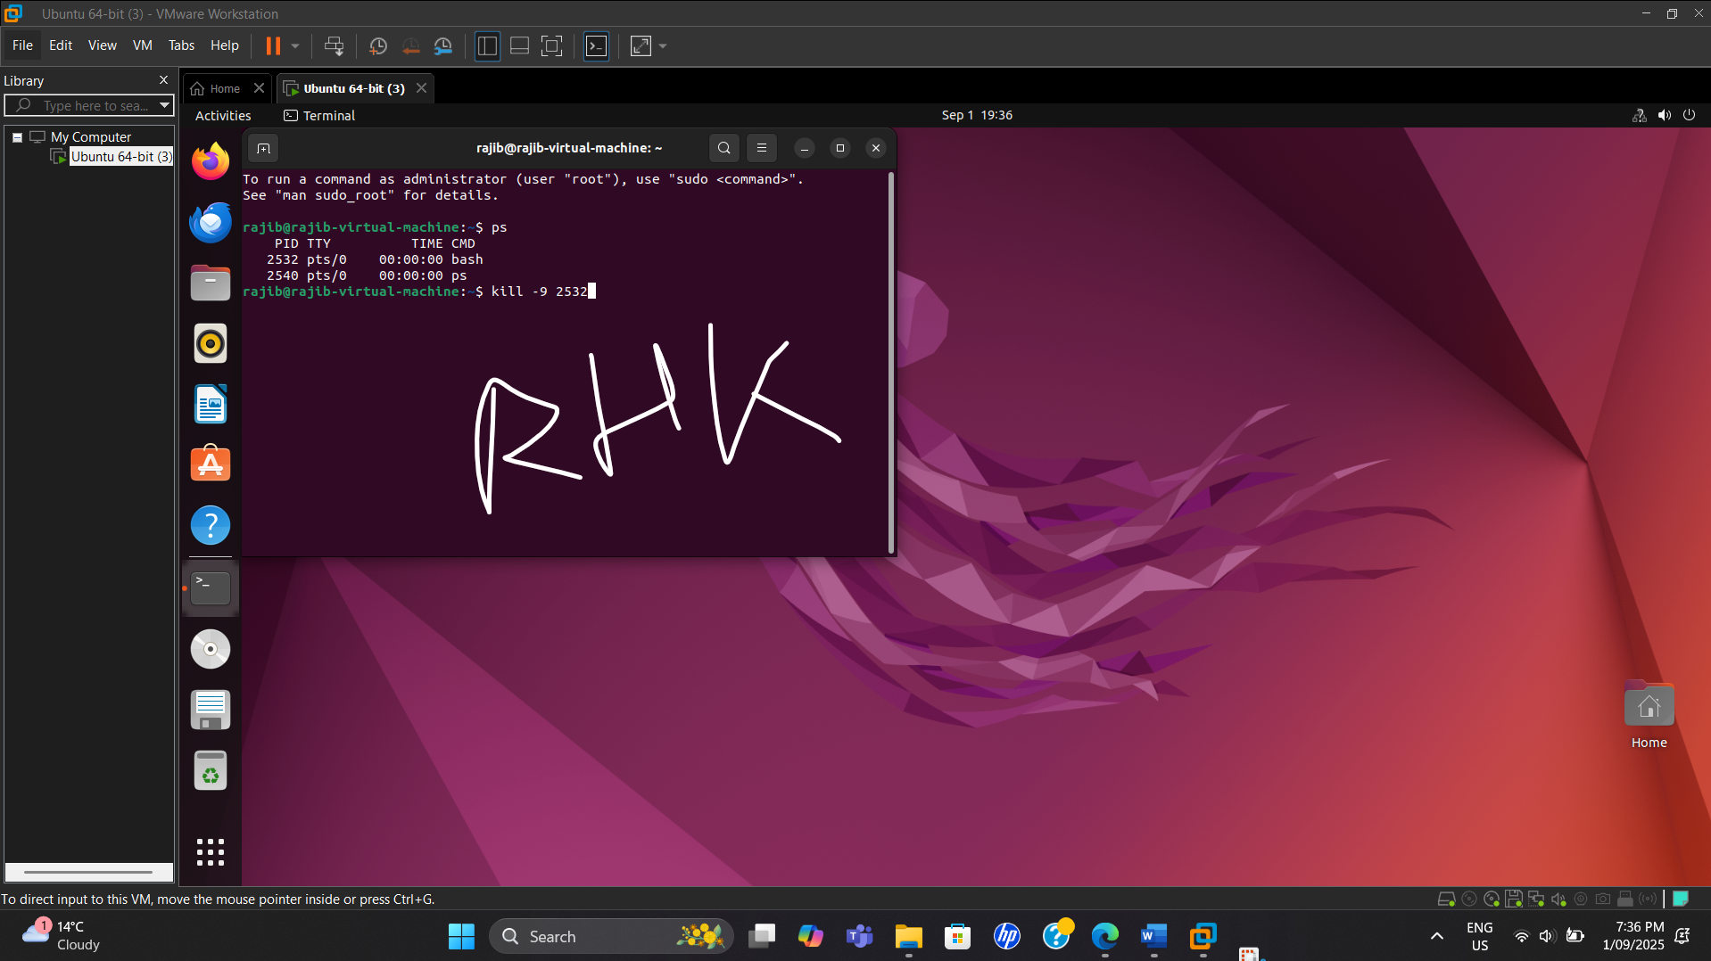

**Step 2: Installing Packages**

1. Update the package repository:

*sudo apt update*

**Screenshot**

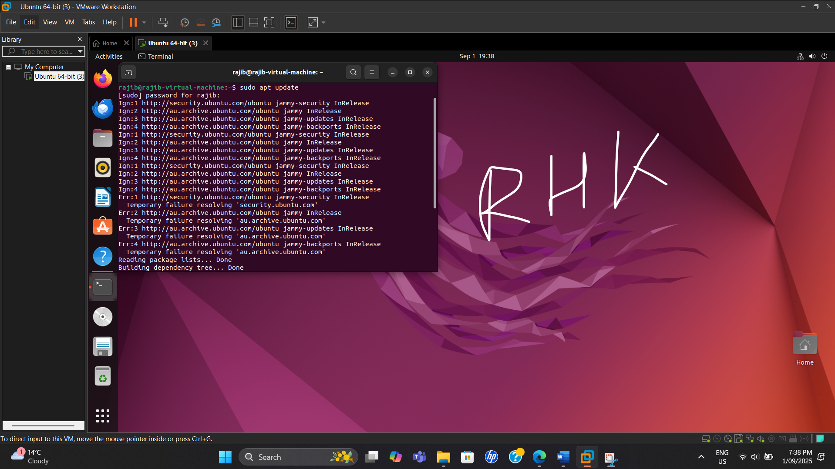

1. Install a new package:
   * Install the htop package (an alternative to top):

*sudo apt install htop -y*

* + Take a screenshot of the installation process.

**Screenshot**

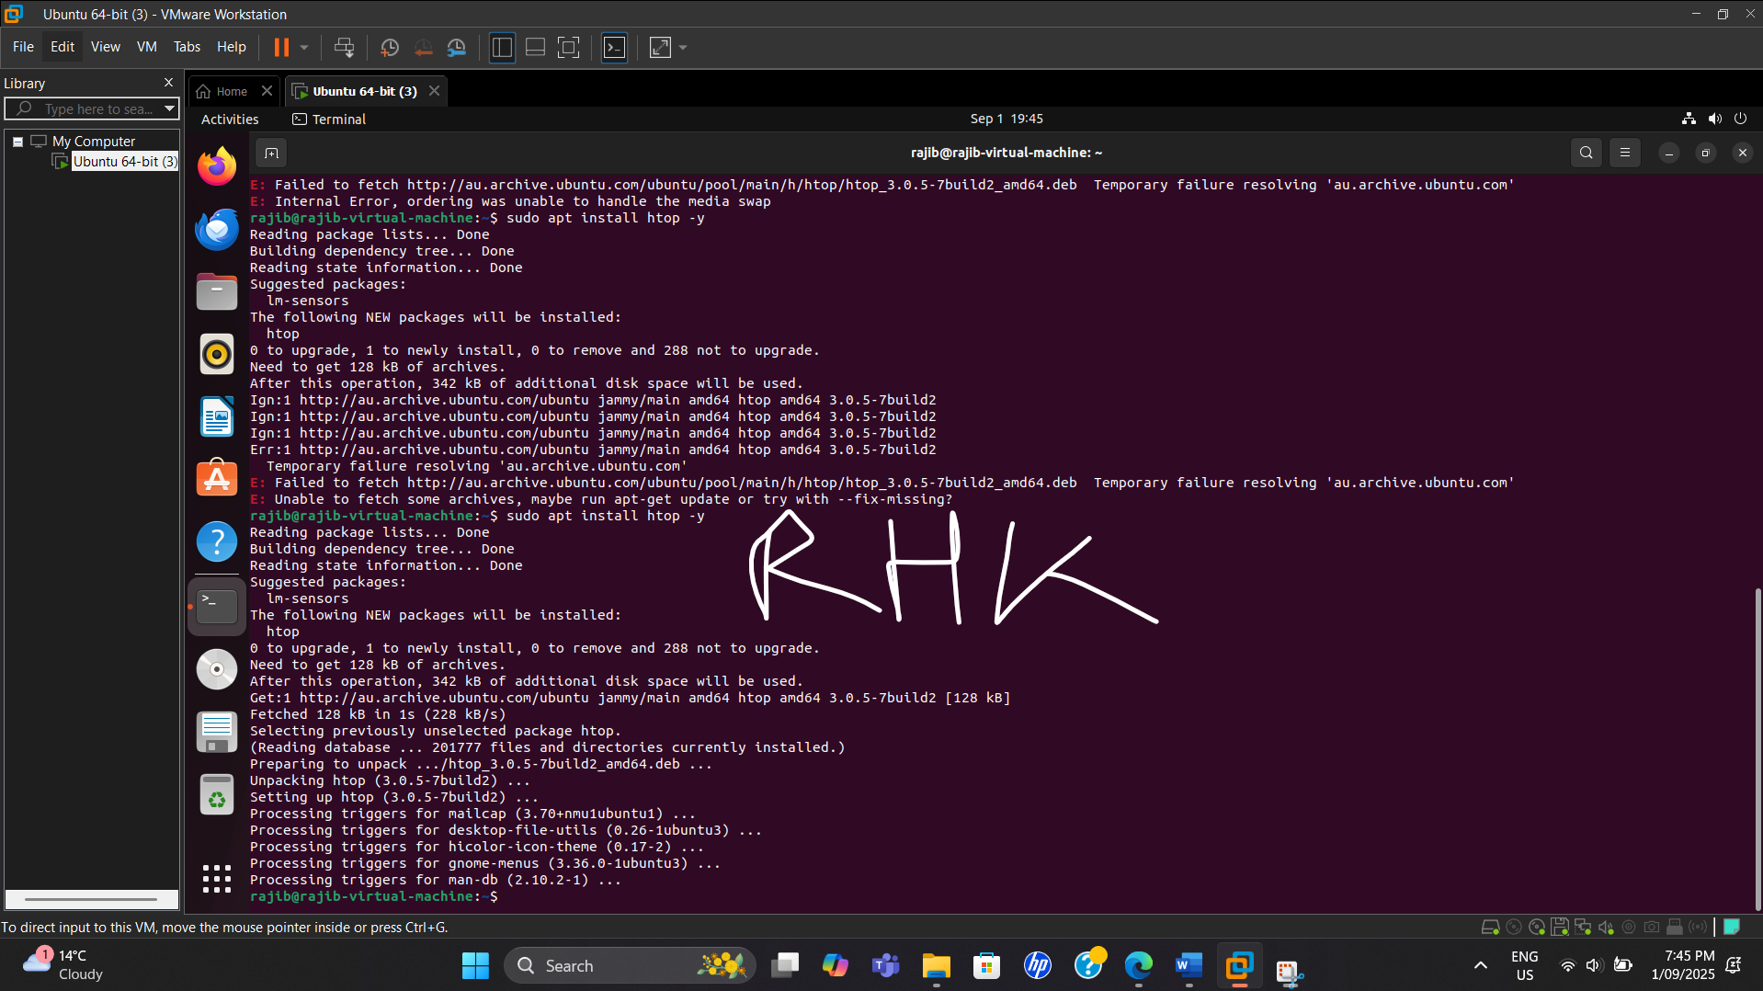

1. Verify the package installation by running:

*htop*

* + Take a screenshot of the htop interface.

**Screenshot**

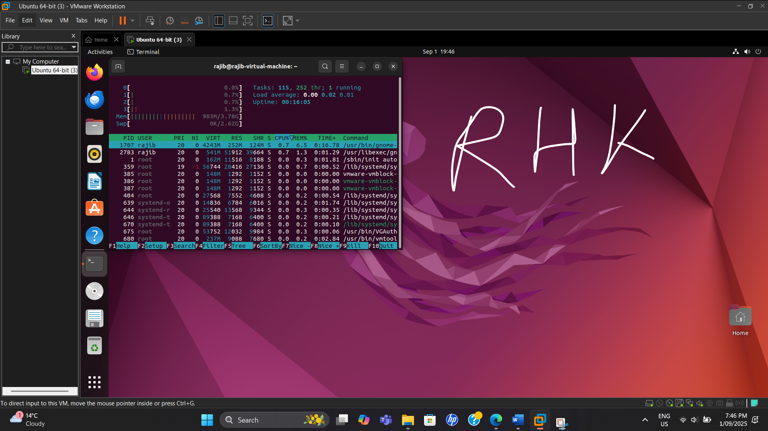

**Step 3: Creating and Managing Users and Groups**

Take screenshots of each command output.

1. Create a new user named student1:

*sudo adduser student1*

**Screenshot**

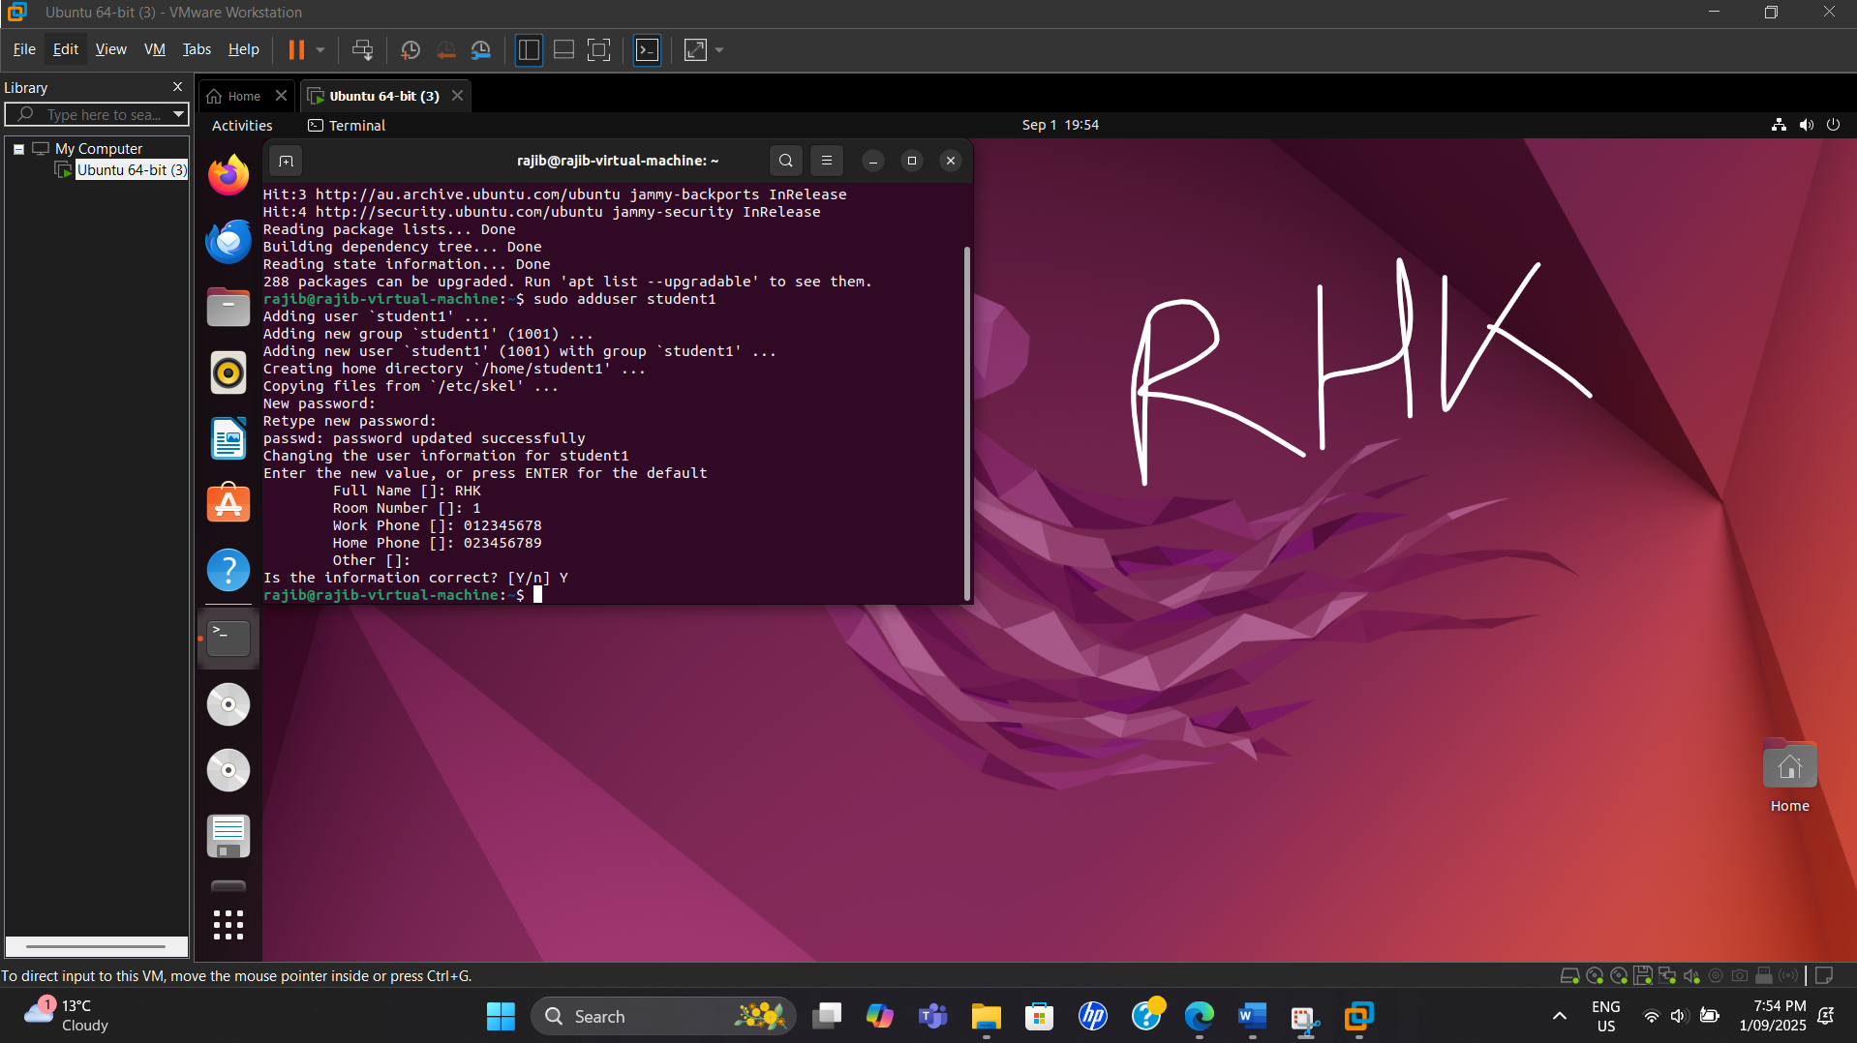

1. Create a group called sysadmins:

*sudo groupadd sysadmins*

**Screenshot**

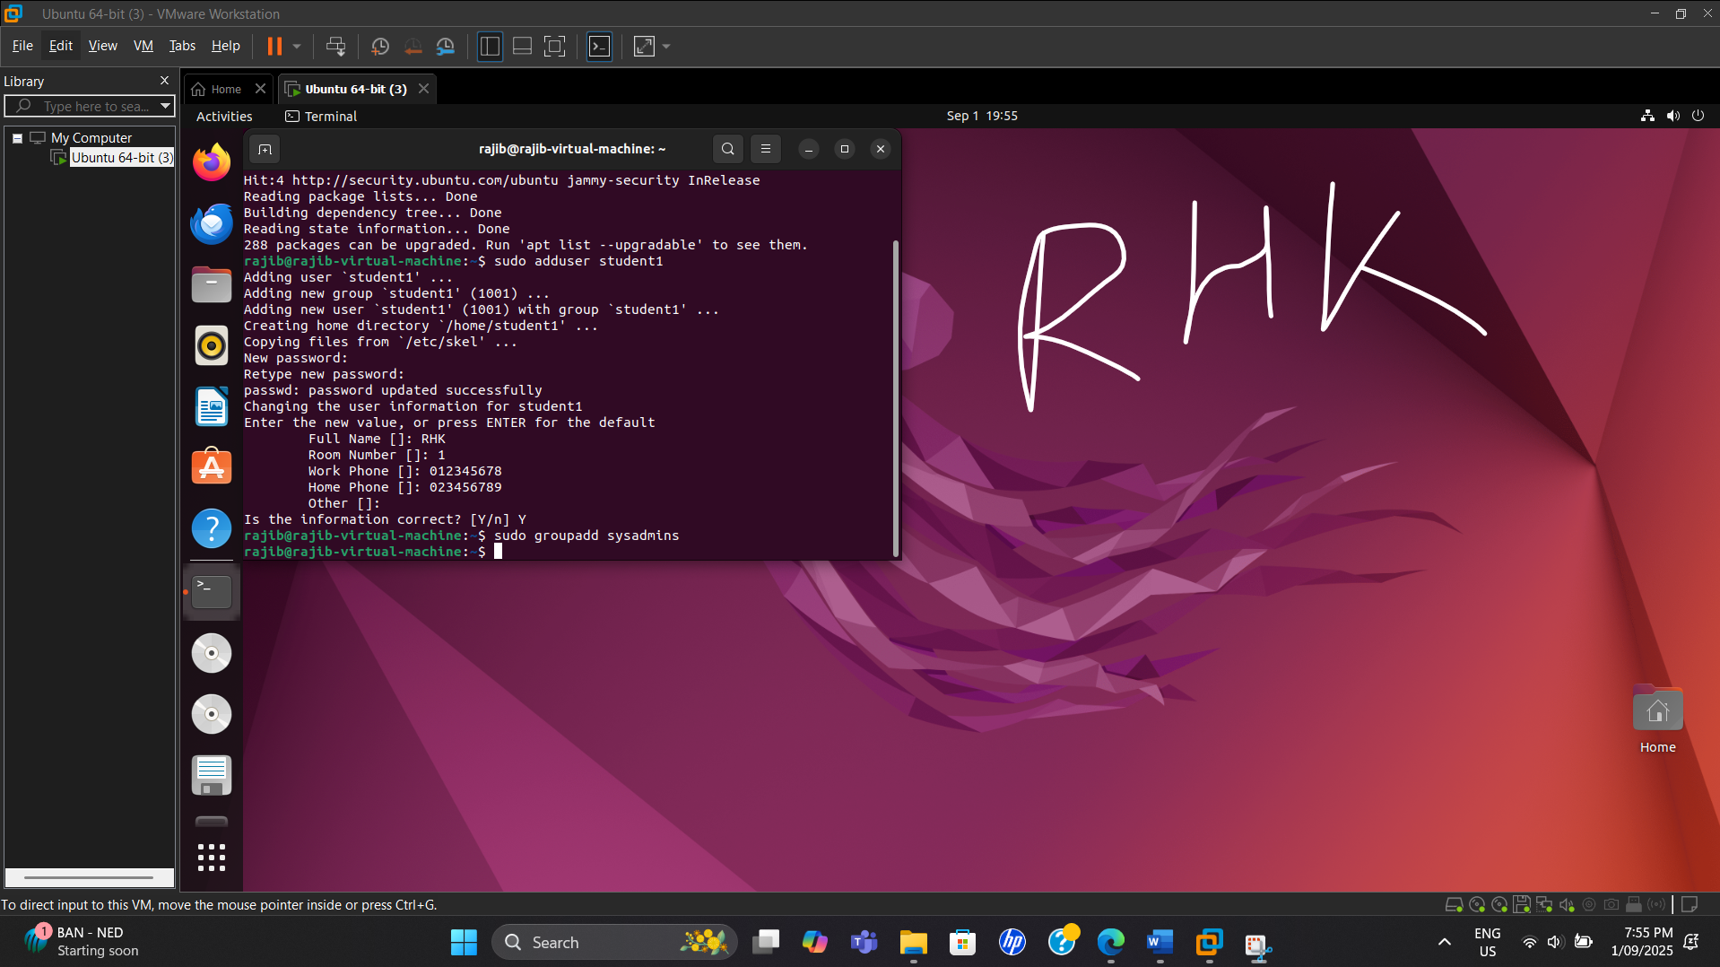

1. Add student1 to the sysadmins group:

*sudo usermod -aG sysadmins student1*

**Screenshot**

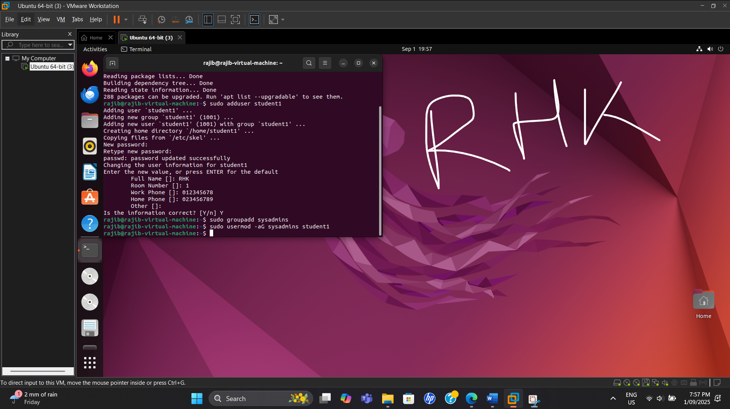

1. Verify the user and group creation:

*id student1*

*groups student1*

**Screenshot**

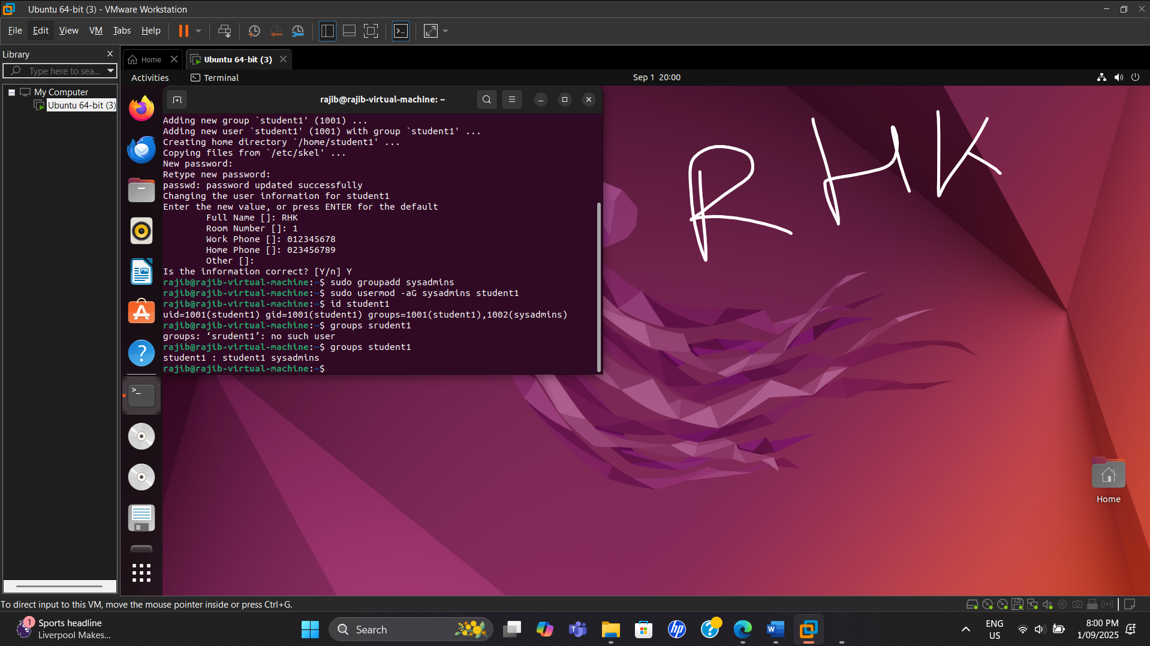

1. Switch to the new user and confirm permissions:

*su - student1*

**Screenshot**

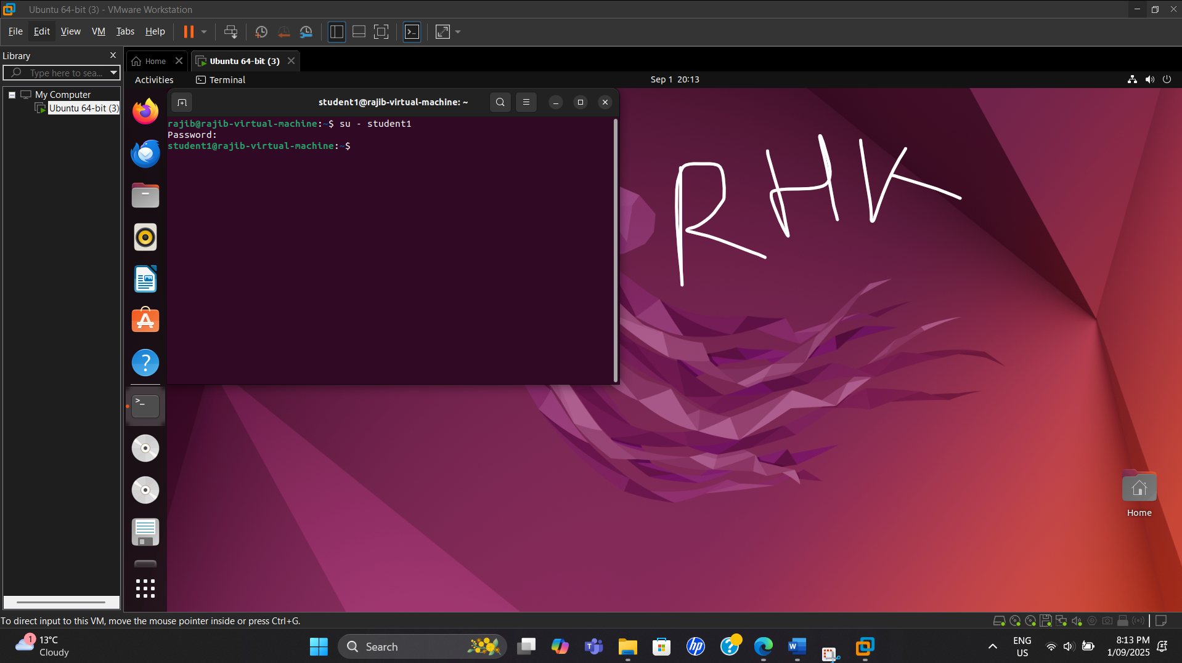

**Step 4: Inspecting and Setting File Permissions**

Take screenshots of each command output

1. Create a new file and set custom permissions:

*touch /home/$USER/securefile.txt*

**Screenshot**

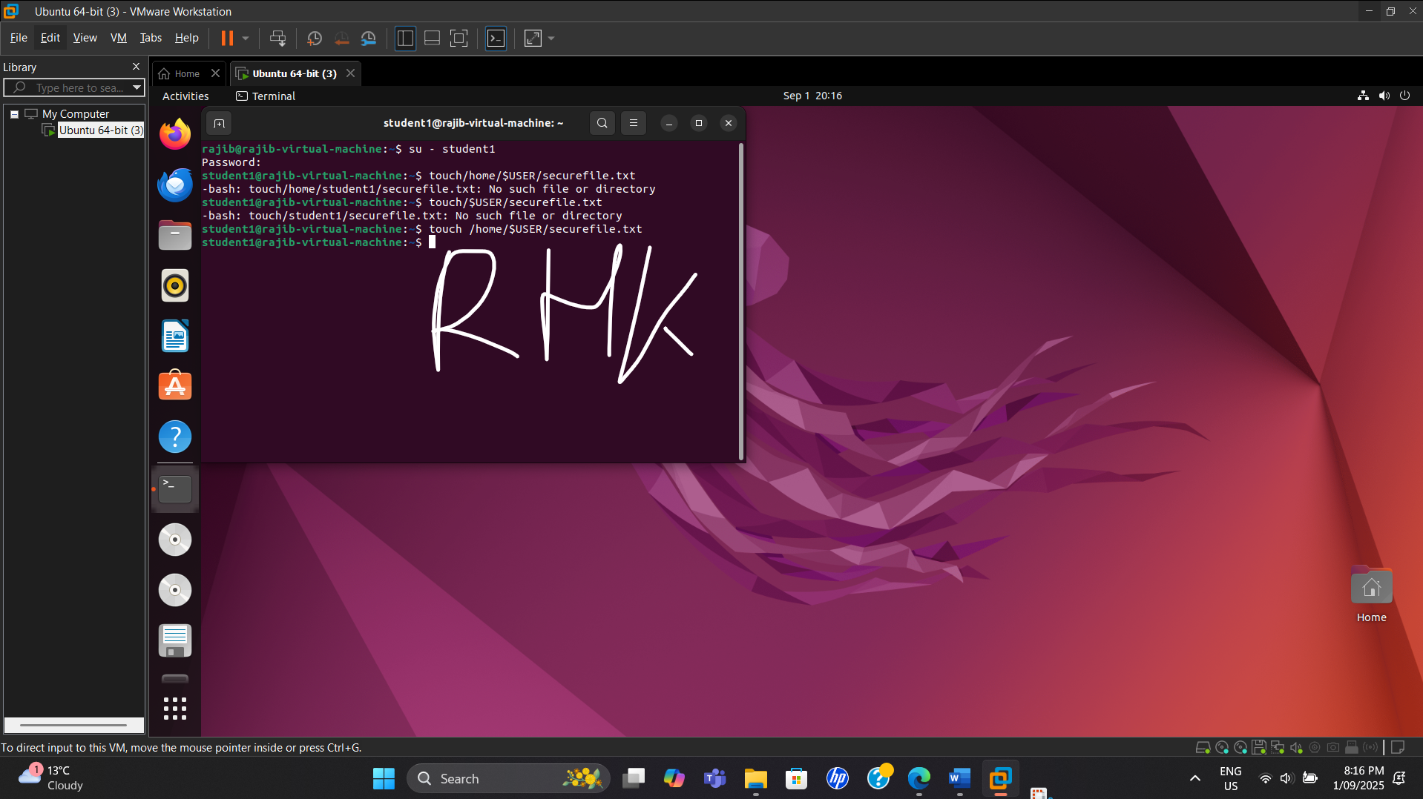

1. Restrict access to only the owner:

*chmod 600 /home/$USER/securefile.txt*

**Screenshot**

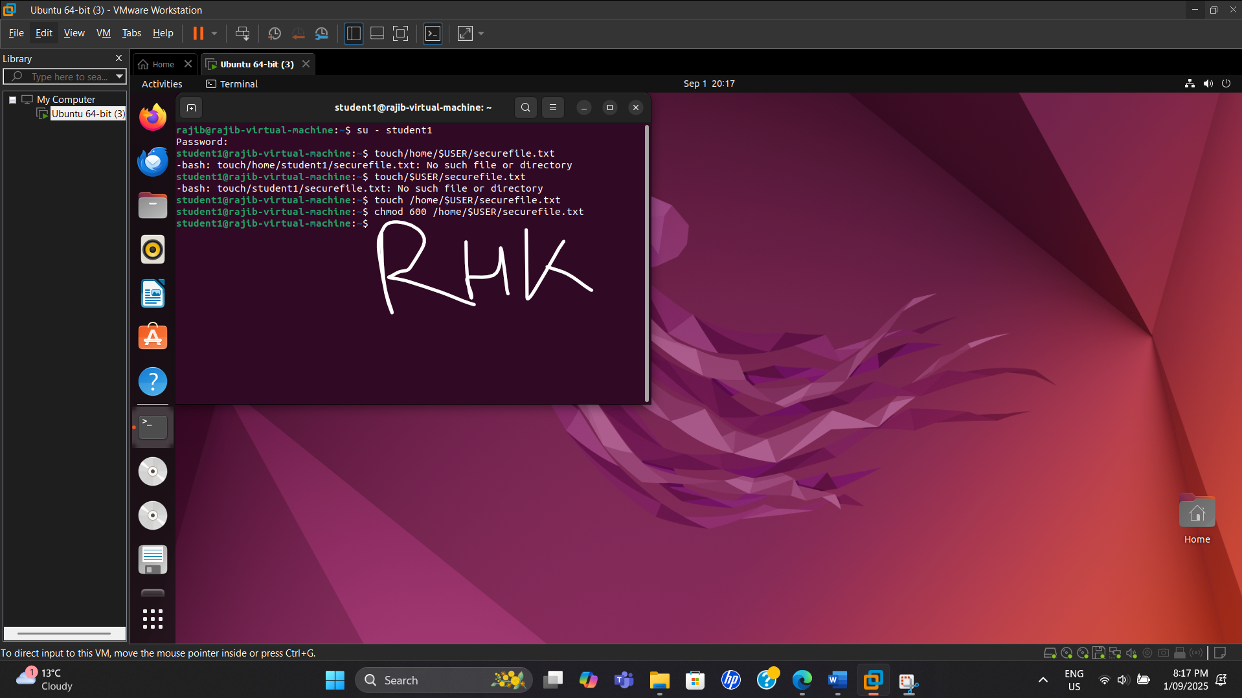

1. Verify permissions:

*ls -l /home/$USER/securefile.txt*

**Screenshot**

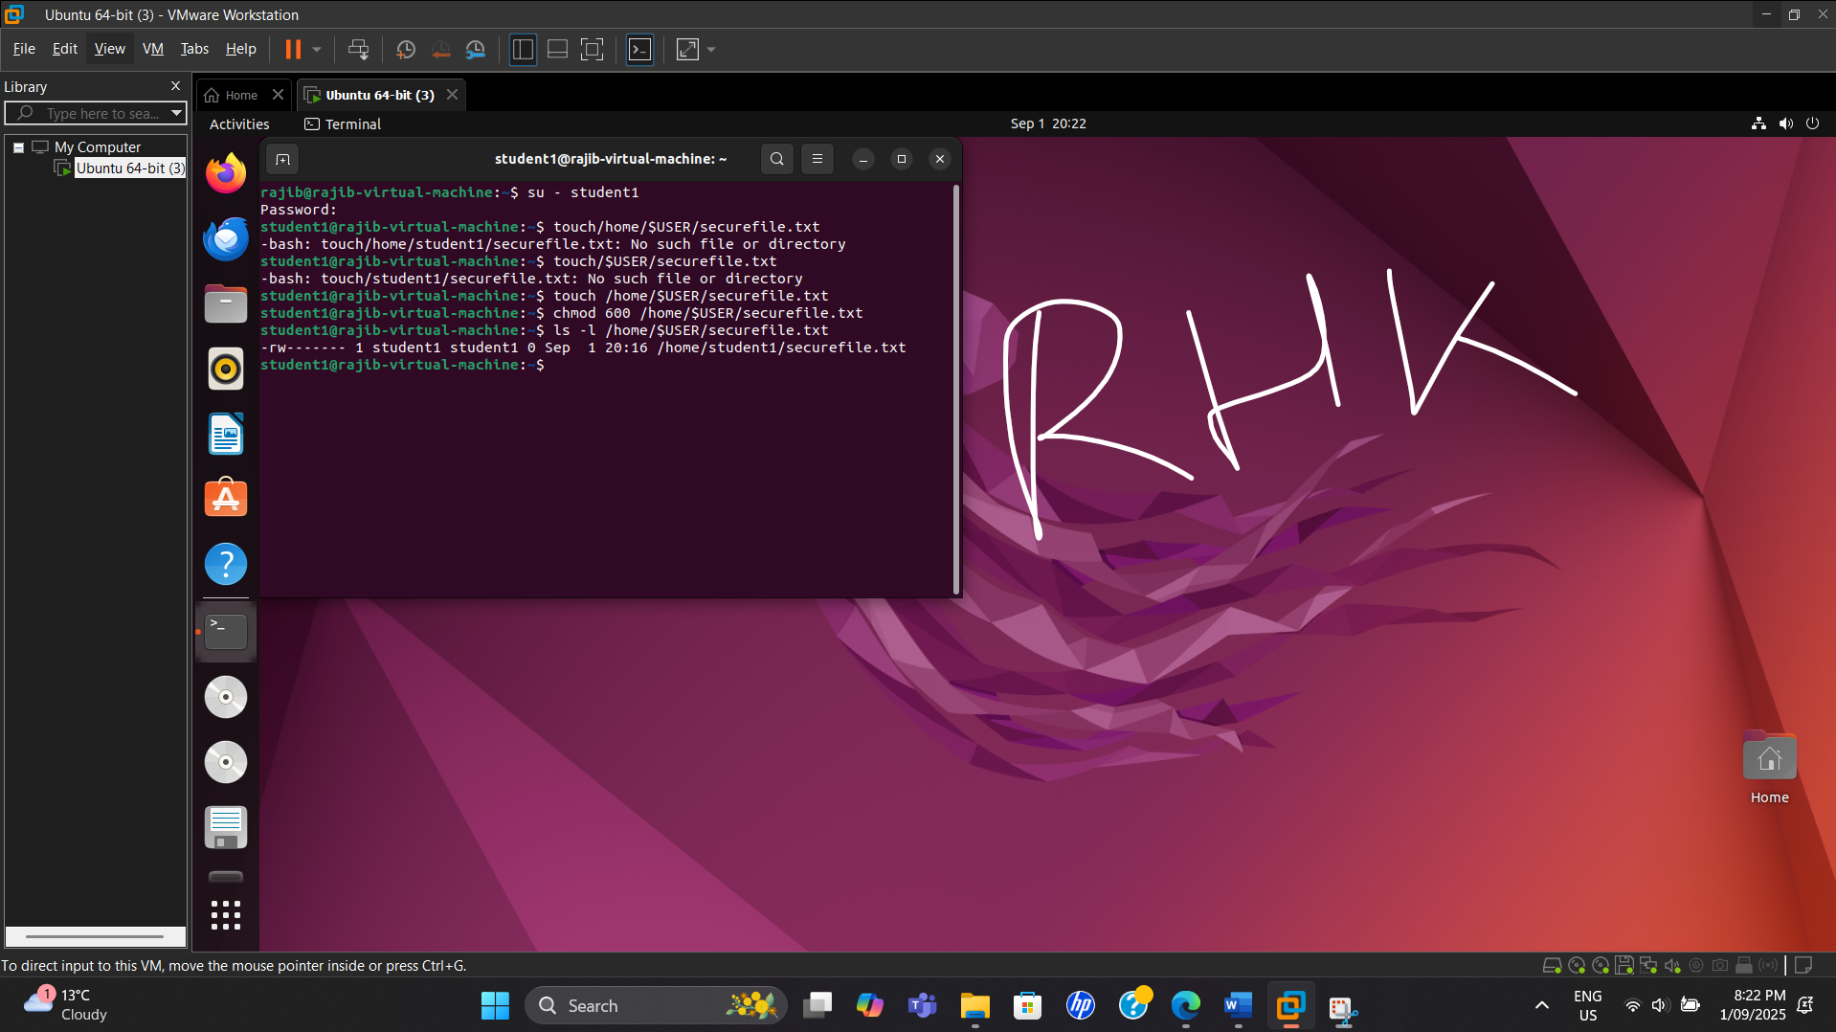

1. Change ownership of the file to the sysadmins group:

*sudo chown :sysadmins /home/$USER/securefile.txt*

**Screenshot**

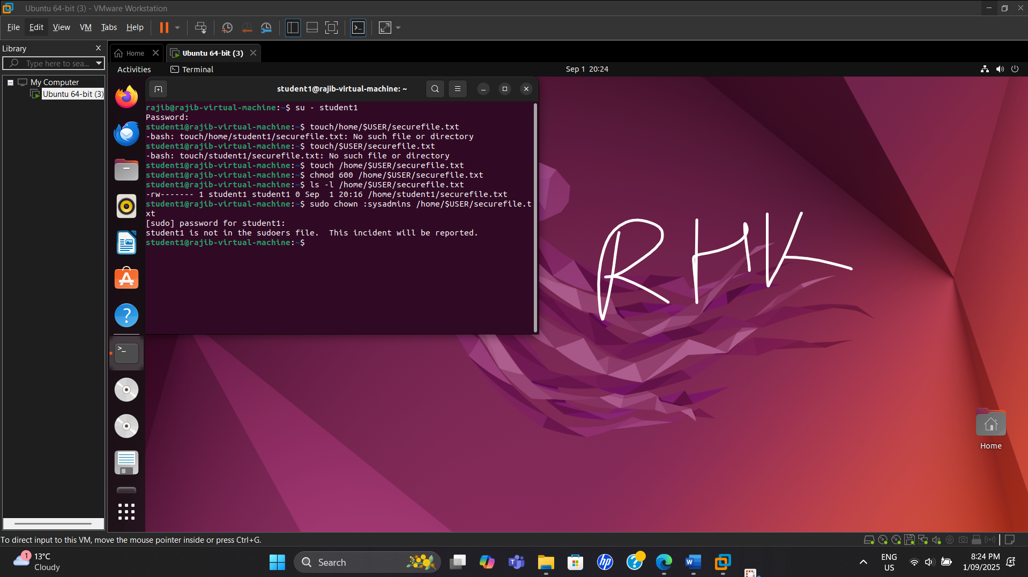

**Step 5: Managing and Monitoring Services**

Take screenshots of each command output.

1. Check the status of a running service (e.g., SSH):

*systemctl status ssh*

**Screenshot**

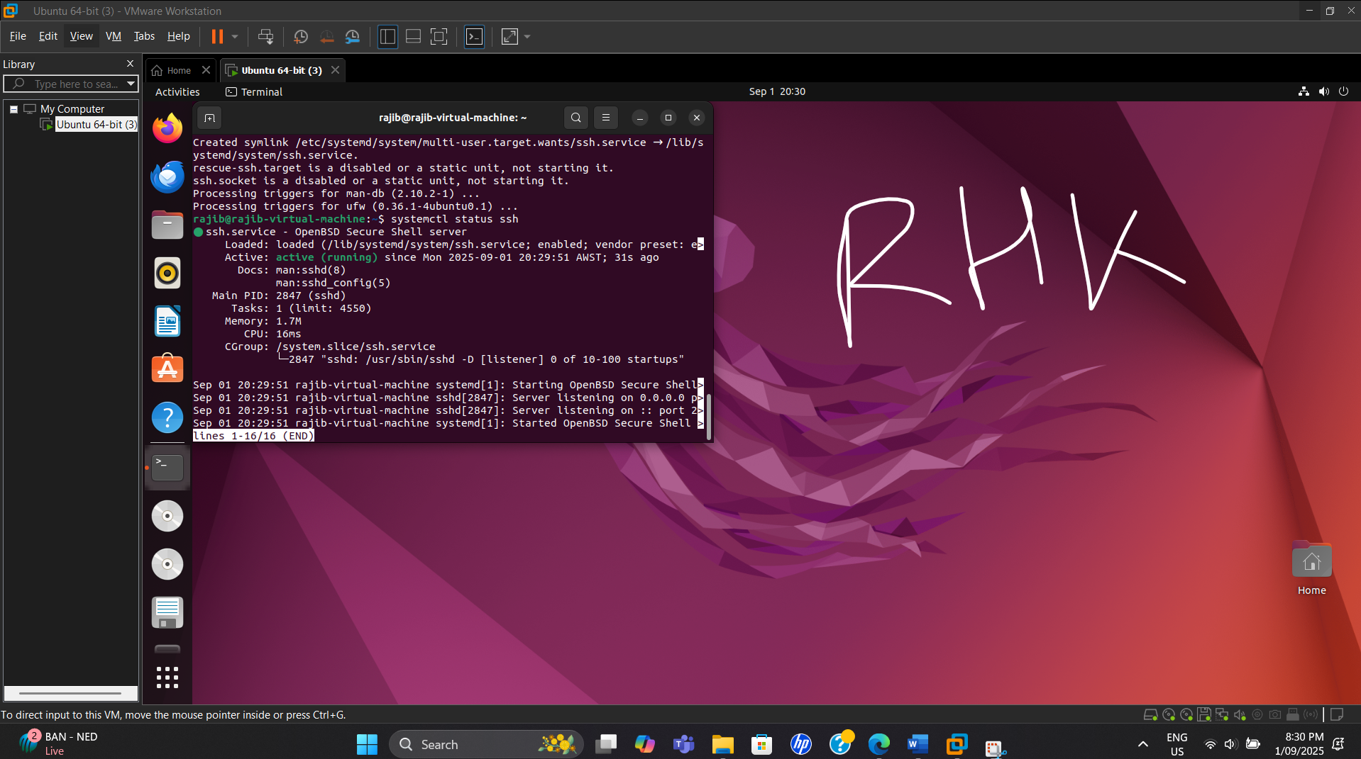

1. Stop the service:

*sudo systemctl stop ssh*

**Screenshot**

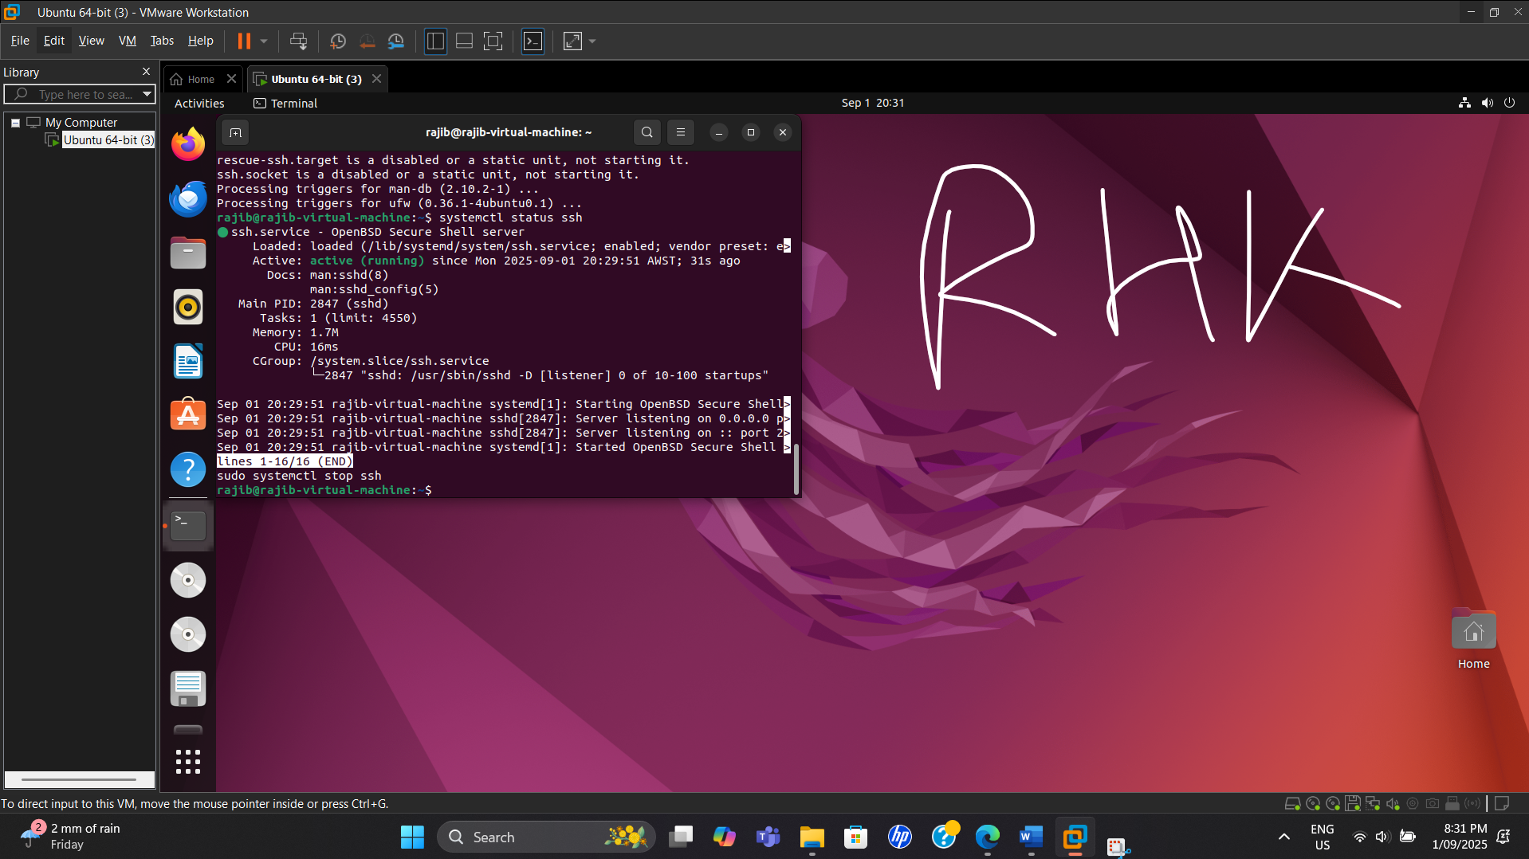

1. Restart the service:

*sudo systemctl start ssh*

**Screenshot**

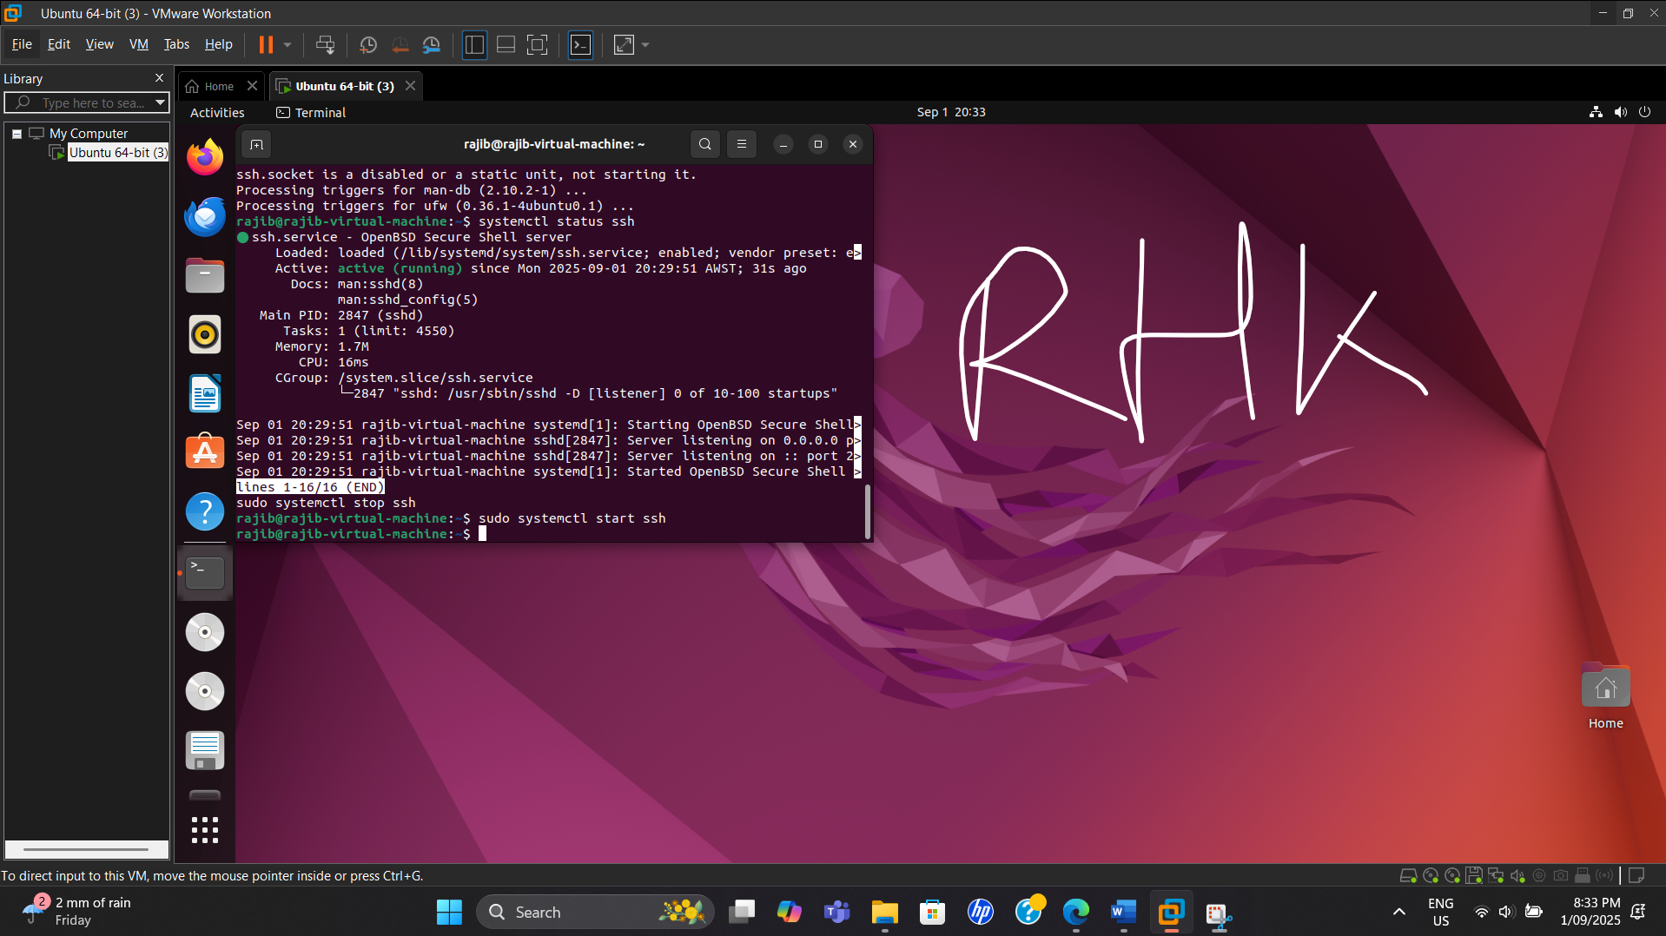

1. Disable an unnecessary service (e.g., cups for printers):

*sudo systemctl disable cups*

**Screenshot**

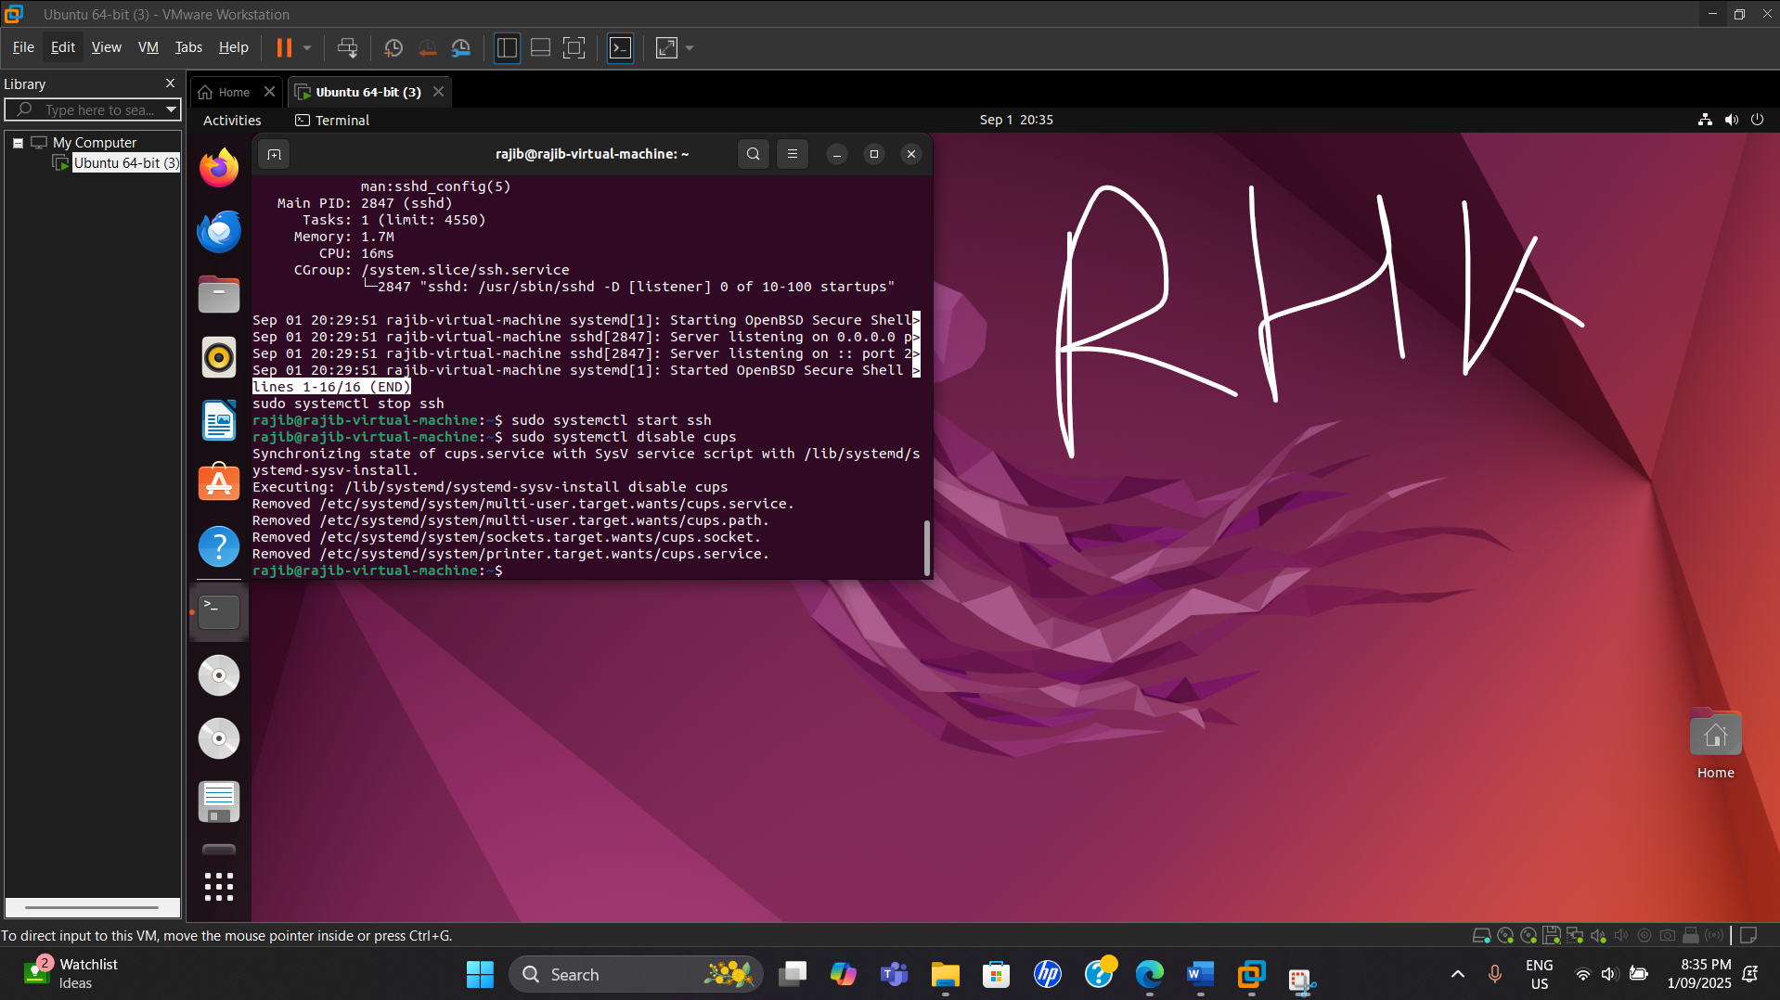

1. Verify service management with:

*systemctl list-units --type=service --state=running*

**Screenshot**

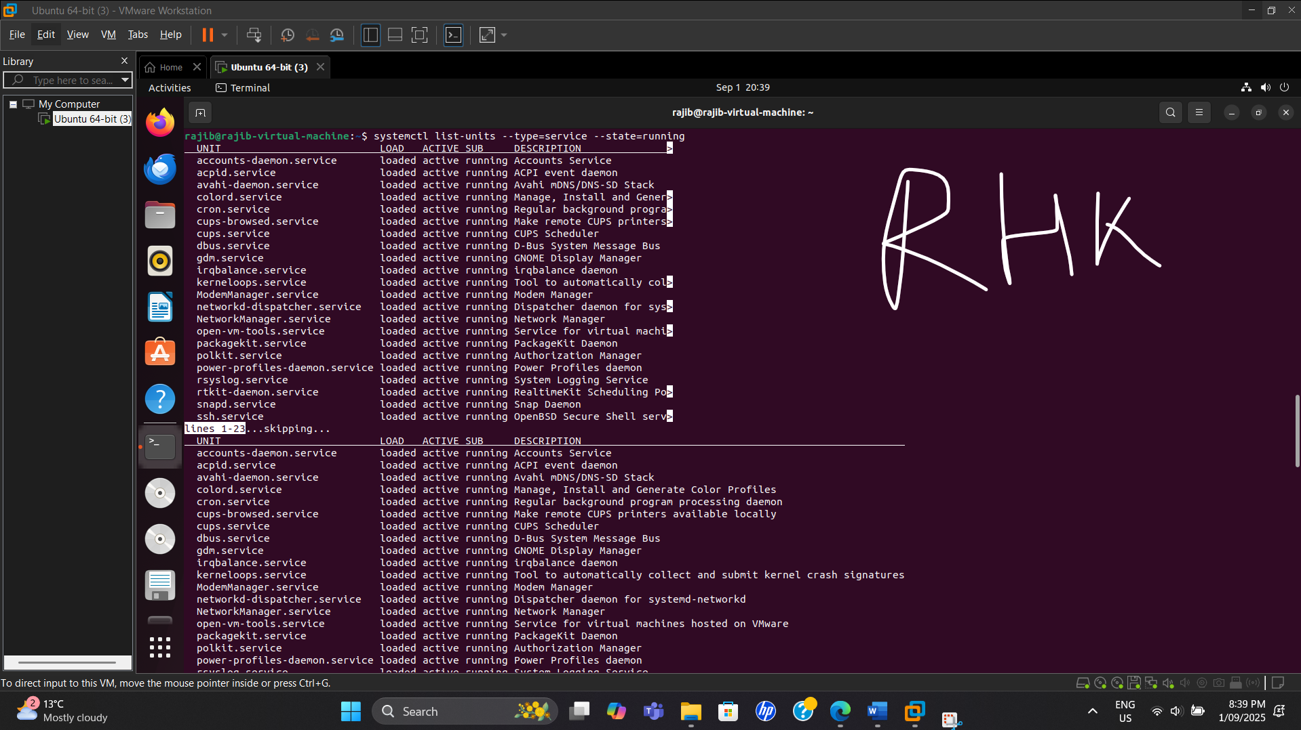

**Step 6: Basic Networking Commands**

Take screenshots of each command output.

1. Check network configuration:

*ip a*

**Screenshot**

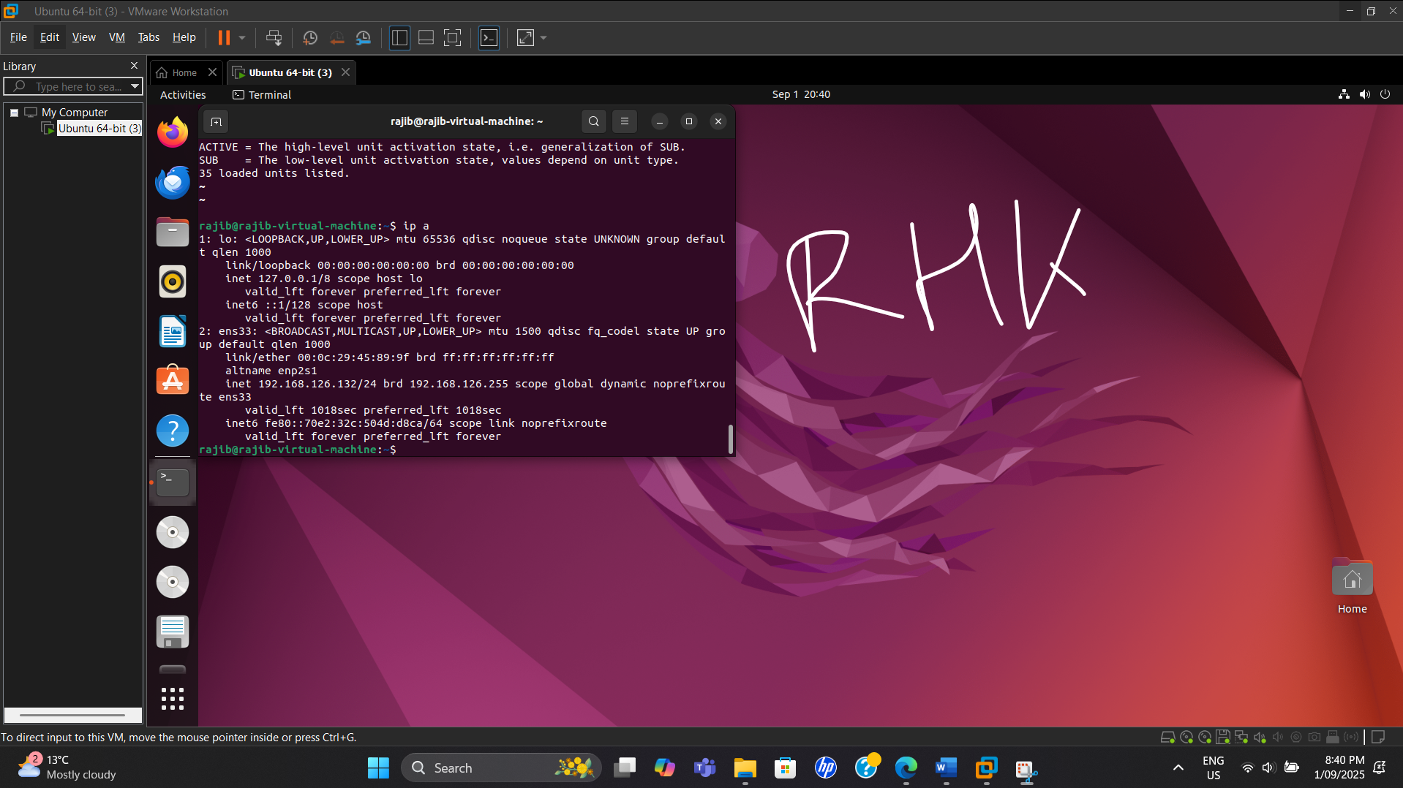

1. Display active network connections:

*netstat -tulnp*

**Screenshot**

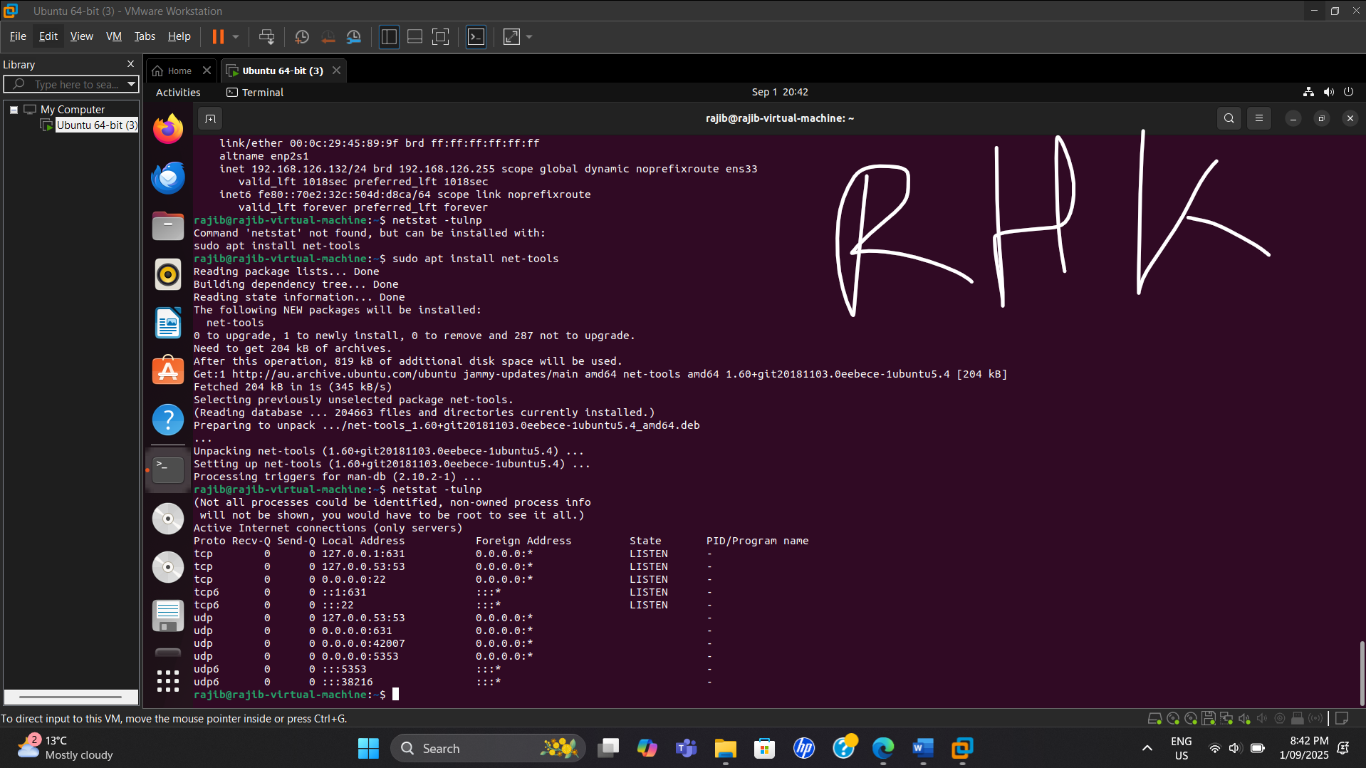

1. Test connectivity to google.com:

*ping -c 4 google.com*

**Screenshot**

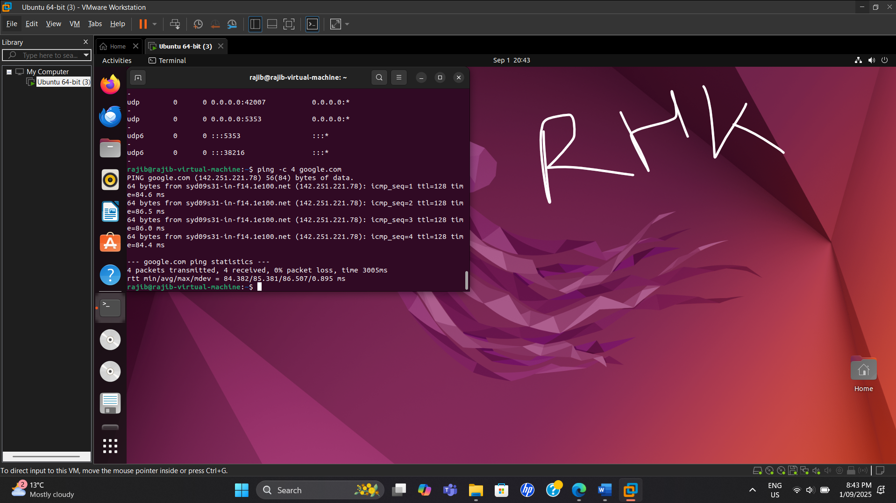

1. Display routing table:

*ip route show*

**Screenshot**

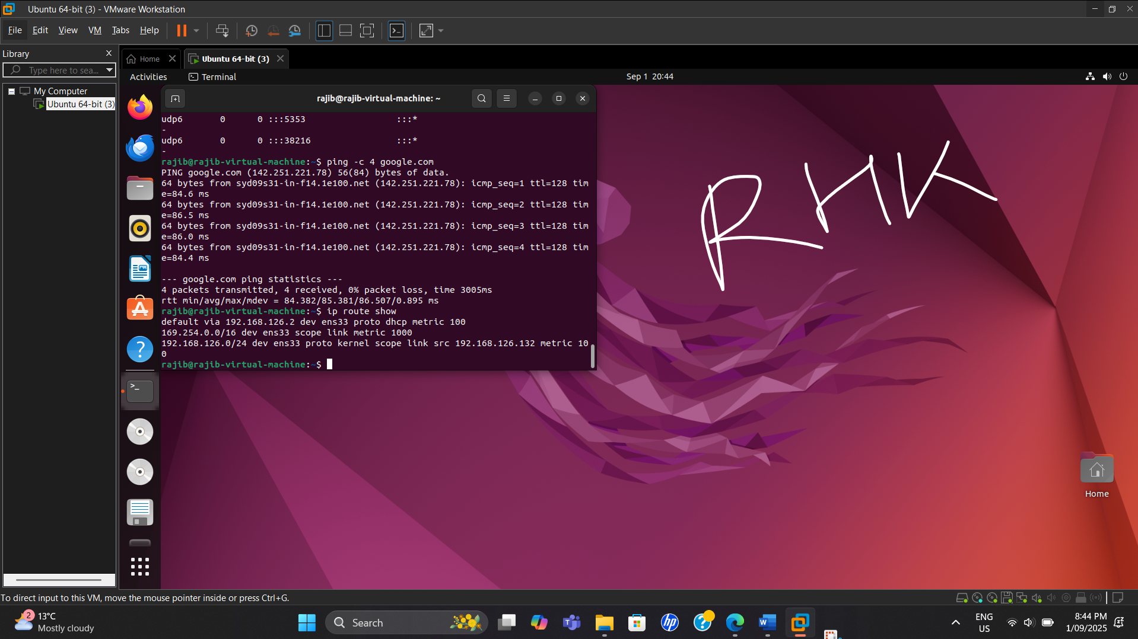

1. Find the IP address of a domain:

*nslookup google.com*

**Screenshot**

